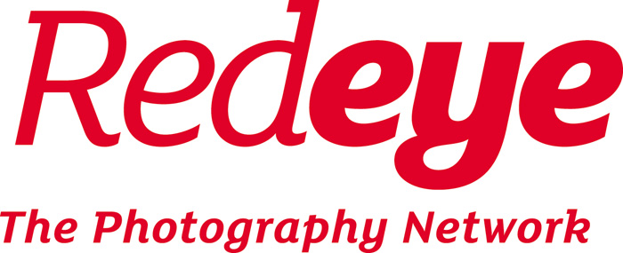

2018 call for nominations for the board of Redeye

Redeye’s Annual General Meeting takes place on Wednesday 26 September 2018 at 18:30, at Centre for Chinese Contemporary Art, Thomas Street, Manchester M4 1EU.

If you would like to stand for election to the board, see below for full details.

If you want more background info, or would like to propose a resolution to be discussed at the AGM, we also advise you to see Redeye’s Practical Guide for Members (www.redeye.org.uk/rules).

The board would like to invite nominations by 7 August 2018 from within the Redeye membership to elect up to two new board members at the AGM in 2018.

Whilst all nominations are welcome, when recruiting new members to the board, we are particularly keen to bring in experiences and perspectives from women, younger creative people and members of minority ethnic groups, in order to help rebalance the gender, age and ethnicity within the board.

There are also particular skills and qualities that are currently underrepresented, and Redeye would benefit from nominees who fulfil any of the following:

- Have experience of registered societies or membership organisations;
- Have connections with or work in the press and media;
- Have connections in politics or the public sector;
- Have legal experience or legislative knowledge relevant to Redeye;
- Understand the digital economy and communications;
- Have recent experiences of human resources practices;
- Already have formal or informal experience of working within a committee or board or as a community activist.

NB you don’t have to fulfil all of the above!

To stand, you need to be a current member, have a nominator who is also a member, and submit your nomination by 9am on Tuesday 7 August 2018, using the nomination form at the end of this document.

Directors need to agree to the following roles and responsibilities; they should:

- Be current Redeye members (unless co-opted)
- Have skills, experience or knowledge relevant to Redeye
- Support Redeye’s aims and objects, and act in the best interests of the organisation
- Understand their responsibilities and ethical requirements as directors
- Commit to attend all board meetings, other meetings and training as needed
- Advocate for Redeye in public and at other events and organisations
- Respect the confidentiality of Redeye’s business
- Understand their duties and powers as summarised in the rules of Redeye
- Agree to adhere to the principles of public life – selflessness, integrity, objectivity, accountability, openness, honesty, leadership. See: www.gov.uk/government/publications/the-7-principles-of-public-life

Skills audit

Redeye’s board calls on skills and expertise in the following areas:

- Board and governance experience
- Management experience
- The photo industry - services and manufacturing
- Knowledge of commercial photographic practice
- Knowledge of arts photography practice
- Photography print and image sales
- Marketing, communications and PR
- Public and strategic programming
- Fundraising and finance
- Registered society sector
- Membership organisations
- Commercial growth / mixed income economy
- Education strategy and research
- Media, journalism, press and the digital economy
- Children and young people in the arts and creative sector
- Finance and accounts
- Activism and corporate social responsibility
- Human resources / personnel
- The law
- Politics and public sector

Ideally the board also reflects the diversity of Redeye’s membership and community.

List of current directors

Directors seeking re-election at the 2018 AGM are as follows:

Elizabeth Wewiora, photographic artist, curator and creative producer
Primary skills: 1, 2, 5, 8, 9, 13, 15, 17

Co-opted directors seeking re-appointment:

Dewi Lewis, photography publisher, book designer, curator, writer, lecturer - previously Arts Centre Founder and Director (Bury Met, & Cornerhouse), arts consultant (Co-opted director)
Primary skills: 1, 2, 3, 5, 6, 7, 12, 14; Secondary skills: 8, 9, 11, 16, 19

Other directors:

Howard Hopwood, Former chair of the board of Harman Technology (Ilford Photo), and deputy chair Cheshire and Warrington Enterprise Partnership
Primary skills: 1, 2, 3, 6, 7, 12; Secondary skills: 16, 20

Tristan Poyser, photographer, photography lecturer
Primary skills: 1, 2, 4, 5; Secondary skills: 7, 15

Howard Barlow, photographer, picture editor, former Chairman of RPS Documentary & Visual Journalism Panel
Primary skills: 1, 2, 4, 6, 14 Secondary skills: 3, 7, 10

Sian Bonnell, photographer, academic and research leader, curator and small publisher
Primary skills: 2, 5, 6, 8, 9, 13, 15 Secondary skills: 1, 17, 20

Director standing down at the 2018 AGM:

Charlie Baker, former photographer, urban planner, co-operative founder and environmental consultant
Primary skills: 1, 10, 11, 17; Secondary skills: 16, 20

Susan Jones, arts activist, researcher, consultant and mentor to artists, small-scale initiatives and digital developments. Writer and former director of a-n. (Co-opted director)
Primary skills: 1, 2, 11, 12, 14, 17, 18; Secondary skills: 7, 20

Nomination form for election to the board of directors of Redeye

If you are standing for election to Redeye’s board you must complete all details below.
- If both the nominee and the nominator will be present at the AGM on 26 September 2018, then scanned or typed signatures are acceptable, and the form may be submitted by email to submissions@redeye.org.uk. By 9:00am on 7 August 2018. Use one of these formats: .PDF, .DOC, .DOCX or .RTF. You should receive an immediate confirmation; if not, please check your spam folder then call 0845 456 0260.
- If either the nominator or nominee will not attend the AGM, the form must be completed, printed, signed by hand and posted to arrive on or before 7 August 2018, to: Redeye, CFCCA, Market Buildings, Thomas Street, Manchester M4 1EU.

Nominee (proposed director)

Title and name:

Job title:

Address:

Email:

Telephone number:

I agree to my name being put forward for election. I understand the roles and responsibilities outlined above.

Signed:

Date:

Nominator (must also be a Redeye member)

Name:

I nominate the above named nominee for election to the board of Redeye.

Signed:

Date:

About the nominee

Below, please tell us why you would make a good director. Please do not write more than 300 words in total. You should include a brief description of why you want to be a director and what specific skills you will bring to the board. Your and your nominator’s name and this text will be circulated to all members before the AGM.

