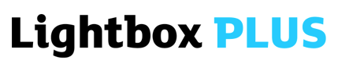

Lightbox Plus 2019 Application Form

All applicants need to complete this form. Alternatively copy the text into a new document using .doc, .docx or .rtf format.

This application form is used to give us an understanding of your work, and your suitability for the Lightbox Plus programme. Whilst we try to take as many applicants onto the course as we are able to, it is important that applicants are the right fit, in order to make the experience as beneficial as possible.

The word counts are maxima – just tell us what you need to.

If you have any questions about the form, or about your suitability for the course, please email lightbox@redeye.org.uk and we will get back to you as soon as possible.

Submit the form and accompanying material to submissions@redeye.org.uk.

Good luck!

The Redeye Team

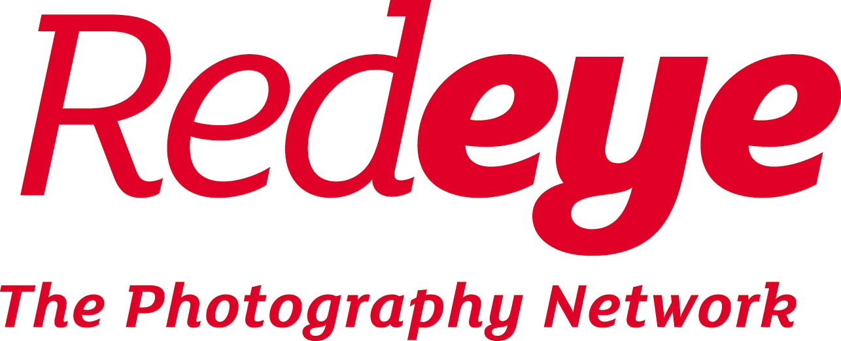

1. About you

Name

Email address

Gender

Phone number

Social media
Postcode

Date of birth

2. Qualifications and Experience

Please tell us why you are applying for Lightbox Plus (No more than 500 words)

Please give us a brief description of how you meet any of the 7 criteria for applying.
(No more than 500 words)

For reference these are:
- Have had a successful project grant e.g. Arts Council England application
- Have exhibited publicly in the UK
- Have had work published or similarly distributed
- Have worked collaboratively on a project with a public outcome
- Have started earning in a creative career
- Have worked as an educator or trainer
- Have an interest in improvements to the photography sector

Please give examples of your work, giving website links to your most ambitious or successful projects/bodies of work

(Please list a maximum of 4 projects)

Please include the statement about you from your nominator.

(Max. 500 words)
Please also include the name and contact details of the person giving the nomination and their relationship to you.

Please give a short description of any other commitments you may have during Sept 2019.

For example: work, care, education, travel.

Thank you for completing the Lightbox Plus application form.

Please return the completed application form to submissions@redeye.org.uk with the subject ‘Lightbox Plus 2019 Application’ by 9am Monday 8th July 2019.

Also remember to include in your email:

- The bursary form if you are applying for a bursary.

- The equal opportunities form (below) - optional

- Optional: up to six digital images of your work (jpeg format, maximum size 3000 pixels in the longest dimension, maximum total email size 10MB). These may be used by Redeye to publish course information.

3. Declaration

Please tick or type a cross to confirm the following:

Tick or X to confirm the following four statements: | TICK or X
I confirm that if I am offered a place, Redeye may use one or more of the images I supply with this application on its website and social media only in connection with Lightbox Plus.
I understand if offered a place on Lightbox Plus which I accept, I will pay the fees required by the due dates.
I confirm that if I accept a place on Lightbox Plus I will cover my own travel and accommodation costs.
I understand that in the event I withdraw from the course, one week’s notice is required, and that fees due up to that point will not be refunded.
Please tick or X ONE of the following two boxes:
EITHER: I am also applying for a bursary place and have completed the bursary form
OR: I am NOT applying for a bursary place

Please sign or type your name and the date here to indicate the following:

I confirm that the information I have given on this form is correct:

Signature (or typed name): | Date:

Equal opportunities form

At Redeye we are dedicated to making the Lightbox Plus course accessible to all. You may answer any or none of the following. Please note any answers given below will be treated with confidentiality and removed from your application before being handed to the selection panel.

We are particularly interested in supporting those applicants affected by mental health issues. These might include anxiety, depression, autism, dyslexia, dyspraxia or ADHD. We refer to these issues as “neurodivergence”.

If you have any questions about this section of the application process please email lightbox@redeye.org.uk

Are you affected by neurodivergence and if so could you list any conditions?

Please also state if you have any particular access needs connected to these conditions.

Disability:

Non-disabled
Visual impairment
Hearing impairment/Deaf
Physical disabilities
Cognitive or learning disabilities
Mental health condition
Other long term/ chronic conditions
Not known/ Prefer not to say

Ethnicity:

White:
British
Irish
Gypsy or Irish traveller
Any other white background
Mixed:
White and Black Caribbean
White and Black African
White and Asian
Any other Mixed background
Asian/Asian British:
Indian
Pakistani
Bangladeshi
Chinese
Any other Asian background
Black/Black British:
African
Caribbean
Any other Black background
Other:
Arab
Any other ethnic group
Not known/ prefer not to say

