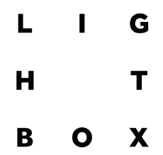
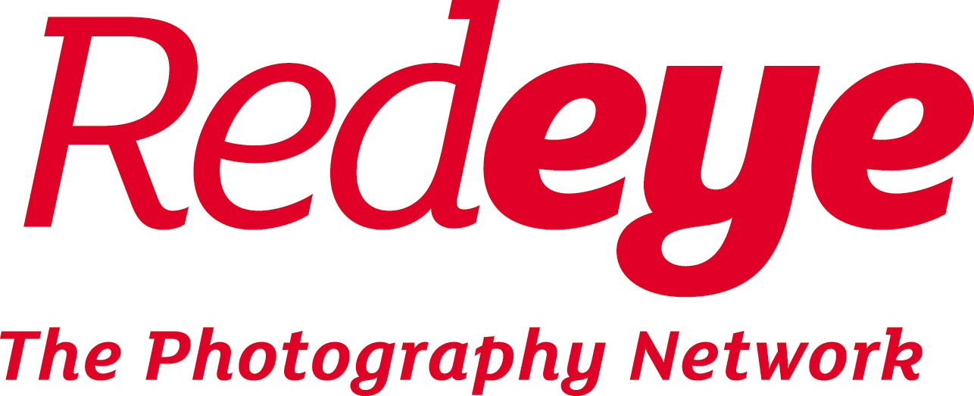

Lightbox Online Application Form

This application form is used to give us a better understanding of your work and your suitability for Lightbox Online. We try to take as many people onto the course as we are able to support and it is important that applicants are the right fit in order to make the programme as beneficial as possible.

At Redeye we celebrate diversity and are dedicate to making all our activities accessible and inclusive, and free from discrimination. We welcome applications to Lightbox from any and all backgrounds. One of the strengths of Lightbox is its broad mix of ages, genders, ethnicities, income levels and personalities.

We are looking for applicants who understand the value of collaboration, and are committed to developing their ideas and practice. We expect participants to be photographers with strong portfolios who want to take the next step in their career. We are much less concerned with the length of professional experience.

If you find a written application difficult, we are happy to accept applications in other formats. Please email lightbox@redeye.org.uk for more details.

If you have any questions about the form or about your suitability for the course please email lightbox@redeye.org.uk and we will get back to you as soon as possible.

Good luck!

The Redeye Team

1. Basic information

Name

Email address

Phone number

Postcode

Portfolio website and/ or social media

2. About you and your experience

Please tell us why you are applying for Lightbox (Up to 500 words)

We are interested to hear your motivations for applying for this course so that we can make sure it’s right for you. Please make sure you have read the course description carefully.

Please give us a brief overview of your work (Up to 500 words)

This is where we would like to hear about your photography; what interests you, how do you approach your projects, what kind of photographs do you like to create?

Please list any relevant experience and/ or qualifications

If you prefer you can attach a CV instead of answering here.

If you have any relevant qualifications you can list them here. Your experience could be collaborative projects you’ve worked on, or examples of where your work has been published (online, in publications, through exhibiting etc.)

Please note that this is not a requirement for the course, we just want to hear about your experience so far.

3. Declaration

Please tick or type a cross to confirm the following:

Tick or X to confirm the following four statements: | TICK or X
I confirm that if I am offered a place, Redeye may use one or more of the images I supply with this application on its website and social media only in connection with Lightbox.
I confirm that if I accept a place on Lightbox Online I will pay the fees required by the due dates.
I understand that in the event I withdraw from the course, one week’s notice is required, and that fees due up to that point will not be refunded.
I understand that I am responsible for making sure I have a reliable internet connection to access the course.
I confirm that I will attach up to six images (see below).
Please tick or X ONE of the following two boxes:
EITHER: I am also applying for a bursary place and have completed the bursary form
OR: I am NOT applying for a bursary place

Please sign or type your name and the date here to indicate the following:

I confirm that the information I have given on this form is correct:

Signature (or typed name): | Date:

Thank you for completing the Lightbox online application form.

4. Images

With your application please include up to six images that illustrate a recent project or the kind of work you are interested in taking further (JPEG format, maximum size 3000 pixels along the longest edge, maximum email size 10MB).

Submission

Please return the completed application form along with up to six images and bursary form if relevant to submissions@redeye.org.uk with the subject ‘Lightbox Online’ by 11:59pm on Sunday the 22nd November 2020.

Equal opportunities form

At Redeye we celebrate diversity and are dedicated to making the Lightbox Online course accessible and inclusive to all. To check how we are doing, it is very helpful if you can complete this optional equal opportunities form. You may answer any or none of the following. Please note any answers given below will be treated with confidentiality and removed from your application before being handed to the selection panel.

We welcome applications from any and all backgrounds, regardless of age, gender, ethnicity, disability, income level, social class or sexual orientation; particularly those who are currently underrepresented in the photography industry.

We also welcome applications from anyone who considers themselves to be neurodivergent, whether that includes anxiety, depression, autism, dyslexia, dyspraxia or ADHD. If you need any additional support with your application, or would like to apply in an alternative format please contact lightbox@redeye.org.uk and we will do our best to accommodate those needs.

If you have any questions about this section of the application process please email lightbox@redeye.org.uk.

Are you affected by neurodivergence and if so could you supply any details?

Please also state if you have any particular access needs connected to these conditions and we will do our best to accommodate for them

Do you regard yourself as having a disability?

Non-disabled
Visual impairment
Hearing impairment/Deaf
Physical disabilities
Cognitive or learning disabilities
Mental health condition
Other long term/ chronic conditions
Not known/ Prefer not to say
Please select a box to confirm your ethnicity:

White:
British
Irish
Gypsy or Irish traveller
Any other white background
Mixed:
White and Black Caribbean
White and Black African
White and Asian
Any other Mixed background
Asian/Asian British:
Indian
Pakistani
Bangladeshi
Chinese
Any other Asian background
Black/Black British:
African
Caribbean
Any other Black background
Other:
Arab
Any other ethnic group
Not known/ prefer not to say

3. Declaration

Please insert your signature and the date here to indicate the following:

I confirm that the information I have given on this form is correct

Name/Signature: | Date:

