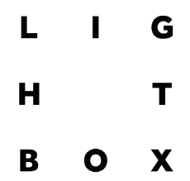

Lightbox 2017-18 Application Form

All applicants need to complete this form. Alternatively copy the text into a new document using .doc, .docx or .rtf format.

This application form is used to give us a better understanding of your work, and your suitability for the Lightbox programme. Whilst we try to take as many applicants onto the course as we are able to, it is important that applicants are the right fit, in order to make the collaborative experience as beneficial as possible.

We are less concerned with the length of any professional experience; we are looking for applicants with a strong drive and work ethic; who understand the value of collaboration; and who are already producing strong work with a commitment to developing their practice further.

If you have any questions about the form, or about your suitability for the course, please email lightbox@redeye.org.uk and we will get back to you as soon as possible.

Good luck!

The Redeye Team

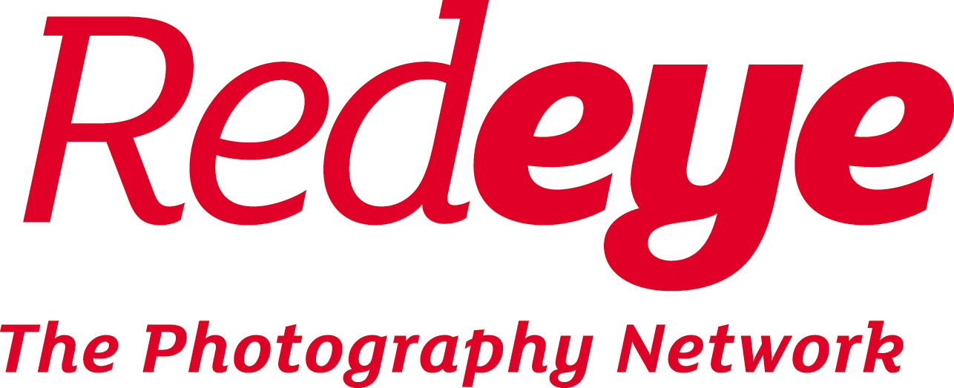

1. About you

Name

Email address

Gender

Phone number

Postcode

Date of birth

2. Qualifications and Experience

Please tell us why you are applying for Lightbox (No more than 500 words)

Please give us a brief overview of your photographic work
(No more than 500 words)

Only complete if you are a photographer, NOT if you are a curator/producer applying for Lightbox

Please list any relevant experience.

This could be collaborative work you have undertaken, or examples of where your work has been published (online, in publications, through exhibiting etc.)

If applying as a curator/producer this could be any projects or groups of people you have managed, or samples of your written work.

(No more than 1000 words)
Please list any relevant qualifications (with name of institution).

Please give a short description of any other commitments you may have during Sept 2017 to July 2018.

For example: work, care, education, travel.

Thank you for completing the Lightbox application form.

Please return the completed application form to submissions@redeye.org.uk with the subject ‘Lightbox 2017-18 Application’ by 9am Monday 3rd July.

Also remember to include in your email:

- The bursary form if you are applying for a bursary.

- The equal opportunities form (below)

- If you are applying as a photographer, up to six digital images (jpeg format, maximum size 3000 pixels in the longest dimension, maximum email size 10MB).

Please remember to also pay your £10 application fee by returning to the website page and clicking the box at the bottom of the page. Your application will not be assessed if payment is not received.

3. Declaration

Please tick or type a cross to confirm the following:

PHOTOGRAPHERS ONLY | TICK or X
I confirm that if I am offered a place, Redeye may use one or more of the images I supply with this application on its website and social media only in connection with Lightbox.
I confirm that I will supply Redeye with one or more images produced during the course, and that these may be used free of charge on Redeye’s exhibited and printed material, website and social media, only in connection with Lightbox.
PRODUCERS / CURATORS ONLY
I confirm that I will supply Redeye with relevant text or other content I produce on the Lightbox course that may be used free of charge on Redeye’s exhibited and printed material, website and social media, only in connection with Lightbox.

ALL APPLICANTS
I understand if offered a place on Lightbox which I accept, I will pay the fees required by the due dates.
I confirm that if I accept a place on Lightbox I will cover my own travel and accommodation costs.
I understand that in the event I withdraw from the course, one week’s notice is required, and that fees due up to that point will not be refunded.
I have paid the £10 application fee (non-refundable)
Please tick ONE of the following two boxes:
EITHER: I am also applying for a bursary place and have completed the bursary form
OR: I am NOT applying for a bursary place

Please sign or type your name and the date here to indicate the following:

I confirm that the information I have given on this form is correct:

Name/Signature: | Date:

Equal opportunities form

At Redeye we are dedicated to making the Lightbox course accessible to all. You may answer any or none of the following. Please note any answers given below will be treated with confidentiality and removed from your application before being handed to the selection panel.

We are particularly interested in supporting those applicants affected by mental health issues. These might include anxiety, depression, autism, dyslexia, dyspraxia or ADHD. We refer to these issues as “neurodivergence”.

If you have any questions about this section of the application process please email lightbox@redeye.org.uk

Are you affected by neurodivergence and if so could you list any conditions?

Please also state if you have any particular access needs connected to these conditions.

Disability:

Non-disabled
Visual impairment
Hearing impairment/Deaf
Physical disabilities
Cognitive or learning disabilities
Mental health condition
Other long term/ chronic conditions
Not known/ Prefer not to say

Ethnicity:

White:
British
Irish
Gypsy or Irish traveller
Any other white background
Mixed:
White and Black Caribbean
White and Black African
White and Asian
Any other Mixed background
Asian/Asian British:
Indian
Pakistani
Bangladeshi
Chinese
Any other Asian background
Black/Black British:
African
Caribbean
Any other Black background
Other:
Arab
Any other ethnic group
Not known/ prefer not to say

