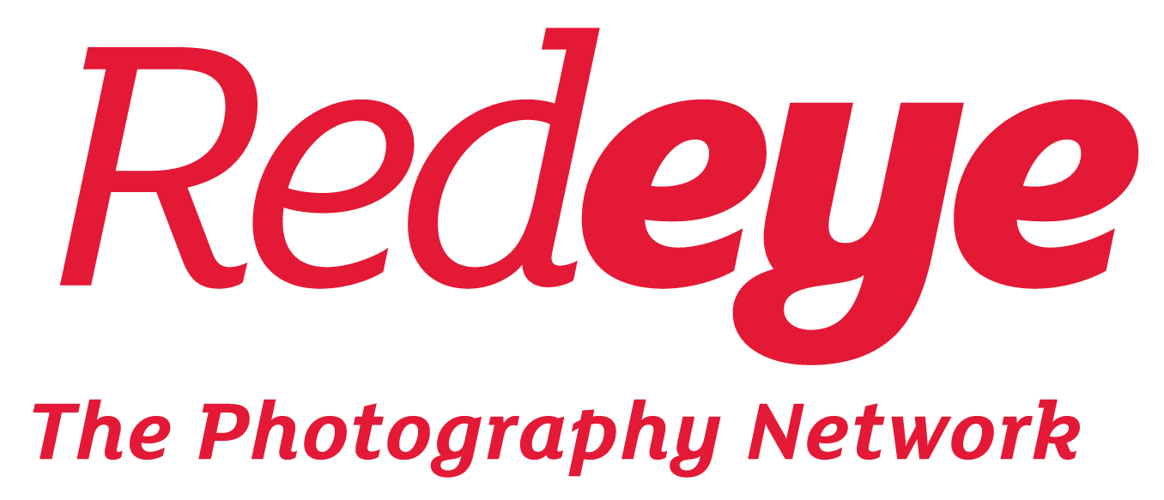

­

***It’s Your Business* Bursaries – January 2022**

**Key information:**

**What are bursaries?**

For the 2022 edition of *It’s Your Business* we are thrilled to have the support of The Photography Show & The Video Show, who will be fully or partially funding a number of places on the course. We will distribute this funding amongst those eligible for a bursary place as fairly as possible, depending on the circumstances of all applicants.

We are aware that the full cost of £190 for It’s Your Business may be a significant financial commitment for those who are on low income or experiencing financial difficulties, and are delighted to be able to offer these free or discounted places.

Bursary places are awarded either in the form of a free place, or a reduced price to attend the course at between a 40 – 70% discount on the full price of £190.

**Who is eligible for a bursary?**

To be considered for a bursary, applicants must live in a household of more than one person with annual income less than £28,000, or have an individual annual income less than £22,000.

If selected, we expect bursary applicants to attend live on Zoom, or watch recordings, of at least 75% of the course. There will be no refunds available for days missed.

We will also ask bursary participants to be available to give short feedback about their progression through the course in the form of a blog or reflective summary. This will be used as a tool for evaluation and documentation, and we may ask for excerpts to be published as a testimonial on our website.

***It’s Your Business* 2022 – Bursary Application Form**

Please note: we will offer as many bursary places as we can depending on how many applications we receive.

Please ensure the information you provide is accurate. Please be prepared to provide evidence for the financial information you provide.

1. **About you**

|  |  |
| --- | --- |
| Your name |  |
| Email address |  |
| Phone |  |
| Postcode and country of residence |  |

1. **About your reasons for applying for a bursary**

|  |  |
| --- | --- |
| Please give a brief overview of how a bursary place would benefit you, mentioning your particular circumstances.  (Up to 100 words) |  |

1. **Finances and Income**

The information below will be used to prove your eligibility for financial support. All information you provide will be treated as confidential. We will never share your information with a third party or use the information for anything other than for consideration for this bursary place.

**Please fill in either box A or box B, then box C and D if appropriate, and the total. Round to the nearest £.**

|  |  |
| --- | --- |
| A. If you live by yourself or in a shared house or similar, please state your individual annual income, i.e. salary, or freelance income. Freelance income should match your most recent tax return |  |
| B. If you live with a partner, please state your household annual income. This is your total combined salaries or freelance income. Freelance income should corroborate with your most recent tax return |  |
| C. Please list and total any other income, for example property, unearned income, inheritance or other |  |
| D. Please list and total any state benefits you receive |  |
| TOTAL ANNUAL INCOME |  |

**Other information**

|  |  |
| --- | --- |
| Please list any dependents you have |  |
| Total of any child maintenance payments you make |  |
| Any other significant financial outgoings you want to tell us about: |  |

Thank you for taking the time to complete the bursary application form. Please sign below and send to [rebecca@redeye.org.uk](mailto:rebecca@redeye.org.uk) by 11:59pm on the 20th January 2022.

**Any questions?**

Please see our FAQs on our website. If you have any further questions please email [chat@redeye.org.uk](mailto:chat@redeye.org.uk) with the subject Lightbox bursary query.

**Signature and date**

Please insert a scan of your signature, or type your name, and add the date, to confirm the following: I hereby declare that the information I have provided is correct and no false claims are made.

Signed/dated: